VENTANA 300X300

* MEJORES RESULTADOS

|  |  |  |  |  |  |  |  |
| --- | --- | --- | --- | --- | --- | --- | --- |
| **Espacio de color** | **Características** | **p(matlab)** |  |  | **p(Python)** |  |  |
| **V** | **Energía** | 2,3188E-20 | 0,00257336 | 5,0022E-16 | 3,02257E-20 | 0,002573358 | 5,00222E-16 |
|  | **medianaHFOUR** | 4,9738E-06 | 9,4061E-35 | 1,0955E-15 | 1,11322E-11 | 1,37385E-21 | 0,000575917 |
|  | **errorCuadraticoN** | 0,00296481 | 1,0822E-26 | 2,1064E-39 | 1,02448E-07 | 3,69304E-10 | 0,047011686 |
|  | **Entropia** | 4,3208E-08 | 0,97833743 | 1,2206E-11 | 4,97385E-06 | 9,40609E-35 | 1,09551E-15 |
|  | **valorpicoHFOUR** | 0,43510248 | 1,5012E-09 | 2,8254E-13 | 0,00296481 | 1,0822E-26 | 2,10638E-39 |

* PEORES RESULTADOS

|  |  |  |  |  |  |  |  |
| --- | --- | --- | --- | --- | --- | --- | --- |
| **Espacio de color** | **Características** | **p(matlab)** |  |  | **p(Python)** |  |  |
| **V** | **varHH** | 0,97012842 | 0,01958578 | 0,01180846 | 0,00934698 | 1,00531E-06 | 3,48176E-12 |
|  | **Entropia** | 4,3208E-08 | 0,97833743 | 1,2206E-11 | 4,97385E-06 | 9,40609E-35 | 1,09551E-15 |
|  | **mediaHH** | 1,1709E-13 | 4,4206E-07 | 0,97679864 | 0,488062978 | 0,521059707 | 0,691675385 |
|  | **mediana** | 0,2058732 | 7,7173E-06 | 0,01126568 | 0,970128418 | 0,019585783 | 0,011808457 |
|  | **Homogeneidad** | 4,8089E-05 | 0,00107637 | 0,24476065 | 4,32082E-08 | 0,978337434 | 1,22058E-11 |
|  | **medianaEDFT** | 0,34712427 | 2,8323E-05 | 3,491E-06 | 1,17088E-13 | 4,42057E-07 | 0,976798642 |

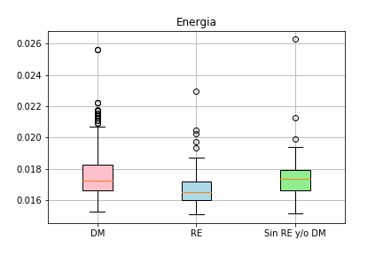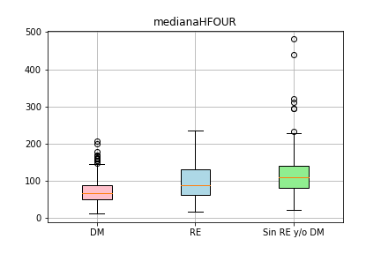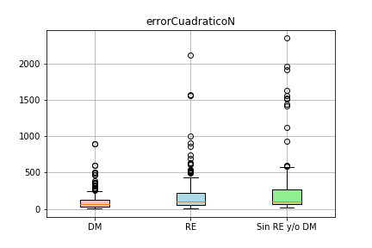 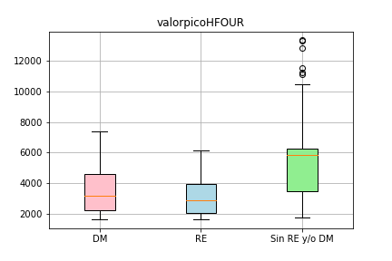 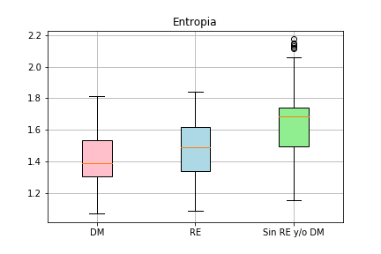

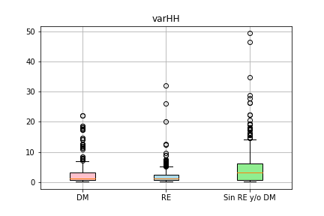 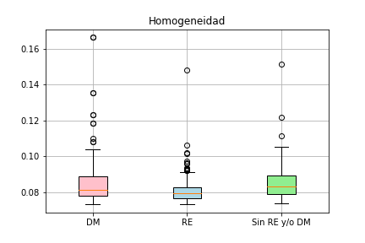

VENTANA 300X300

* MEJORES RESULTADOS

|  |  |  |  |  |  |  |  |
| --- | --- | --- | --- | --- | --- | --- | --- |
| **Espacio de color** | **Características** | **p(matlab)** |  |  | **p(Python)** |  |  |
| **S** | **sSIMN** | 6,5752E-23 | 7,5635E-28 | 0,03159149 | 6,57521E-23 | 7,5635E-28 | 0,031591485 |
|  | **EntropiaSF** | 1,2554E-14 | 3,5802E-50 | 1,2129E-16 | 1,25541E-14 | 3,58017E-50 | 1,21293E-16 |
|  | **valorpicoHFOUR** | 0,03090724 | 1,6361E-29 | 4,0426E-38 | 0,03090724 | 1,63605E-29 | 4,04255E-38 |

* PEORES RESULTADOS

|  |  |  |  |  |  |  |  |
| --- | --- | --- | --- | --- | --- | --- | --- |
| **Espacio de color** | **Características** | **p(matlab)** |  |  | **p(Python)** |  |  |
| **S** | **varHL** | 0,91117818 | 1,4917E-05 | 0,00013557 | 0,911178181 | 1,49167E-05 | 0,000135571 |
|  | **mediaHH** | 0,37929568 | 0,87076859 | 0,63619305 | 0,379295679 | 0,870768593 | 0,636193047 |
|  | **errorCuadraticoDWHT** | 0,00308262 | 0,00033231 | 0,92192868 | 0,003082619 | 0,000332306 | 0,921928684 |

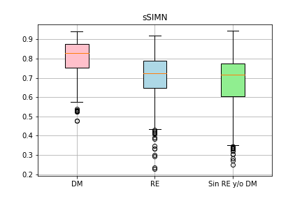 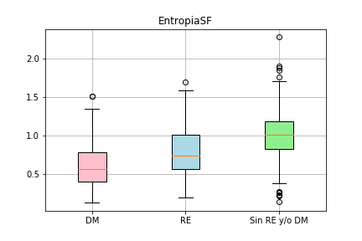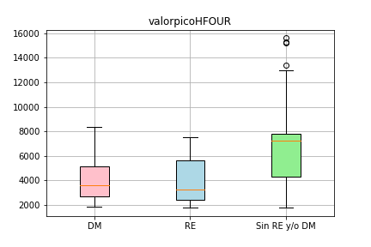

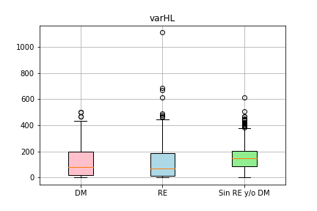 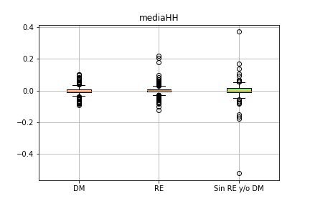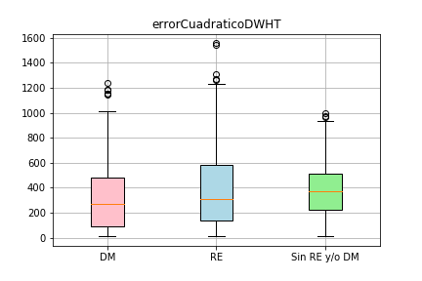

VENTANA 300X300

* MEJORES RESULTADOS

|  |  |  |  |  |  |  |  |
| --- | --- | --- | --- | --- | --- | --- | --- |
| **Espacio de color** | **Características** | **p(matlab)** |  |  | **p(Python)** |  |  |
| **B** | **Energía** | 2,3188E-20 | 0,00063376 | 1,3913E-14 | 2,32E-20 | 0,000634 | 1,39E-14 |
|  | **medianaHFOUR** | 4,6621E-06 | 6,9262E-36 | 2,2886E-16 | 3,16E-12 | 1,97E-23 | 0,000491 |
|  | **errorCuadraticoN** | 0,00306691 | 2,6258E-26 | 7,2222E-39 | 7,22E-08 | 6,84E-10 | 0,078794 |
|  | **Entropia** | 5,9144E-07 | 0,6365835 | 1,0897E-12 | 4,66E-06 | 6,93E-36 | 2,29E-16 |
|  | **valorpicoHFOUR** | 0,87598557 | 1,0058E-09 | 1,0131E-11 | 0,003067 | 2,63E-26 | 7,22E-39 |

* PEORES RESULTADOS

|  |  |  |  |  |  |  |  |
| --- | --- | --- | --- | --- | --- | --- | --- |
| **Espacio de color** | **Características** | **p(matlab)** |  |  | **p(Python)** |  |  |
| **B** | **varHH** | 0,89998793 | 0,01889867 | 0,01707597 | 0,013554 | 9,25E-07 | 5,62E-12 |
|  | **mediana** | 2,3751E-06 | 0,70134745 | 2,267E-06 | 0,899988 | 0,018899 | 0,017076 |
|  | **difwaveletHL** | 0,03932406 | 0,01990509 | 0,9944586 | 0,287149 | 7,15E-11 | 2,98E-07 |
|  | **valorintensidadHFOUR** | 0,00265577 | 0,06335153 | 0,37069344 | 0,875986 | 1,01E-09 | 1,01E-11 |
|  | **contraste** | 0,33389438 | 1,1356E-15 | 2,133E-10 | 0,3857 | 0,796292 | 0,240746 |
|  | **var** | 6,2585E-12 | 4,0485E-13 | 0,00969731 | 0,039324 | 0,019905 | 0,994459 |

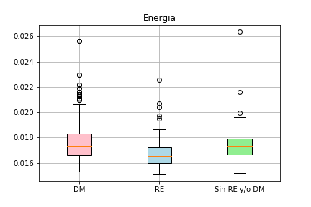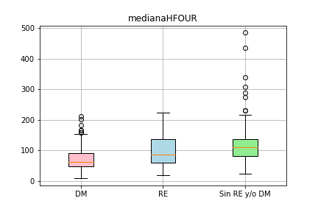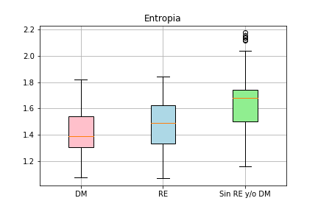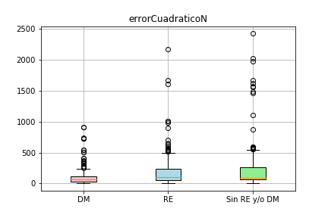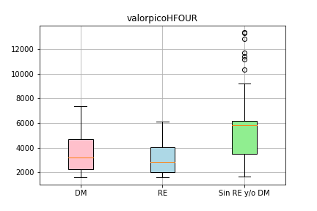

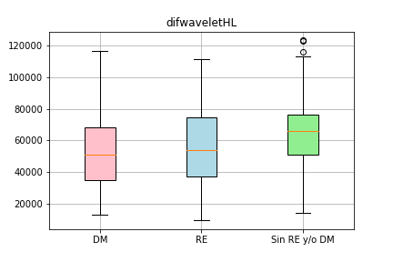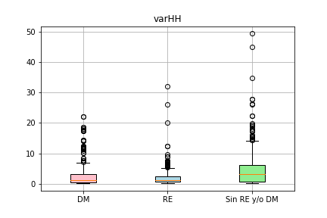 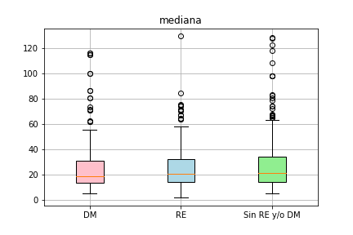 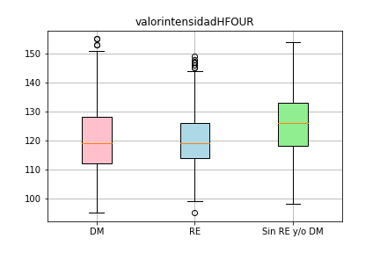 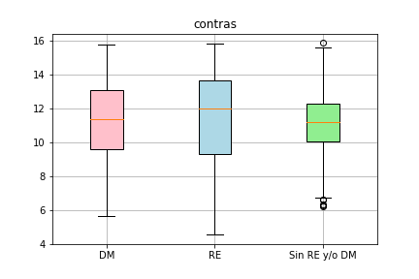

VENTANA 150X150

* MEJORES RESULTADOS

|  |  |  |  |  |  |  |  |
| --- | --- | --- | --- | --- | --- | --- | --- |
| **Espacio de color** | **Características** | **p(matlab)** |  |  | **p(Python)** |  |  |
| **V** | **asimetriaHFOUR** | 1,2926E-62 | 8,0738E-09 | 3,0145E-32 | 1,29258E-62 | 8,07E-09 | 3,01E-32 |
|  | **errorCuadraticoDWHT** | 6,5204E-07 | 1,0912E-49 | 1,6804E-31 | 6,52041E-07 | 1,09E-49 | 1,68E-31 |
|  | **destanEDFT** | 4,0493E-11 | 3,3031E-35 | 6,945E-76 | 4,04932E-11 | 3,3E-35 | 6,95E-76 |

* PEORES RESULTADOS

|  |  |  |  |  |  |  |  |
| --- | --- | --- | --- | --- | --- | --- | --- |
| **Espacio de color** | **Características** | **p(matlab)** |  |  | **p(Python)** |  |  |
| **V** | **l2waveletHL** | 0,96770938 | 5,4143E-08 | 2,1105E-08 | 0,967709383 | 5,41E-08 | 2,11E-08 |
|  | **Entropia** | 7,7734E-05 | 0,96679784 | 1,4938E-05 | 7,7734E-05 | 0,966798 | 1,49E-05 |
|  | **destan** | 0,02641785 | 0,02194295 | 0,95296335 | 0,026417849 | 0,021943 | 0,952963 |

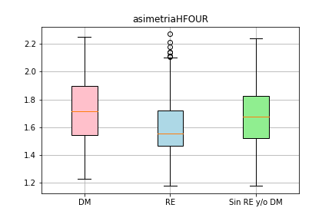 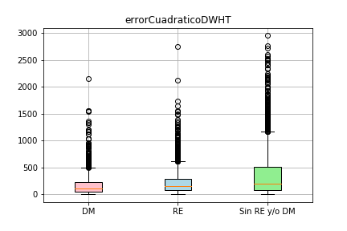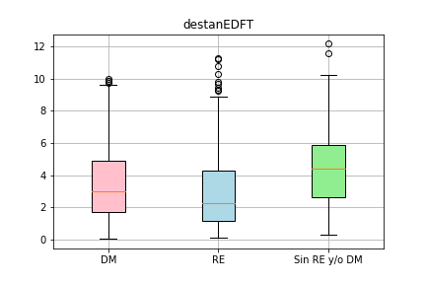

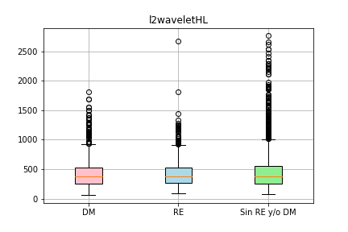 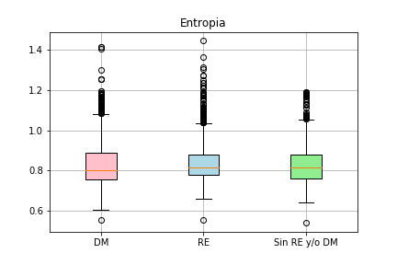 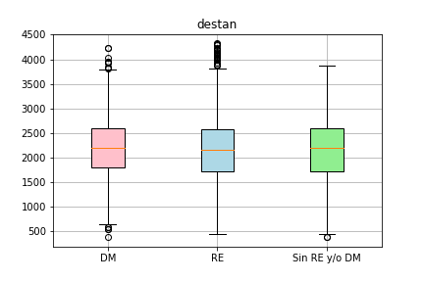

VENTANA 150X150

* MEJORES RESULTADOS

|  |  |  |  |  |  |  |  |
| --- | --- | --- | --- | --- | --- | --- | --- |
| **Espacio de color** | **Características** | **p(matlab)** |  |  | **p(Python)** |  |  |
| **S** | **asimetriaHFOUR** | 8,2548E-48 | 0,33111822 | 1,7602E-53 | 8,25E-48 | 0,331118 | 1,76E-53 |
|  | **pendientereEDFT** | 0,02499376 | 1,4318E-41 | 5,4264E-51 | 0,024994 | 1,43E-41 | 5,43E-51 |
|  | **medianaHFOUR** | 2,1619E-47 | 7,9638E-13 | 3,69E-107 | 2,16E-47 | 7,96E-13 | 3,7E-107 |

* PEORES RESULTADOS

|  |  |  |  |  |  |  |  |
| --- | --- | --- | --- | --- | --- | --- | --- |
| **Espacio de color** | **Características** | **p(matlab)** |  |  | **p(Python)** |  |  |
| **S** | **beta** | 0,95043447 | 0,00244286 | 0,00209403 | 0,950434 | 0,002443 | 0,002094 |
|  | **DiferenciaN** | 0,10345716 | 0,99638313 | 0,06119919 | 0,103457 | 0,996383 | 0,061199 |
|  | **entropiaHH** | 5,4635E-19 | 6,718E-17 | 0,99692922 | 5,46E-19 | 6,72E-17 | 0,996929 |

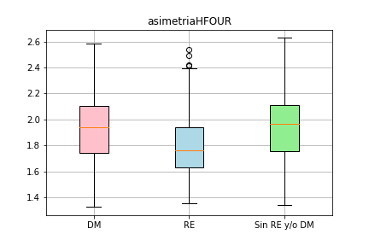 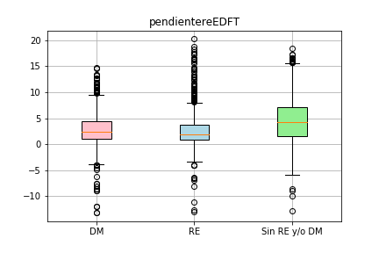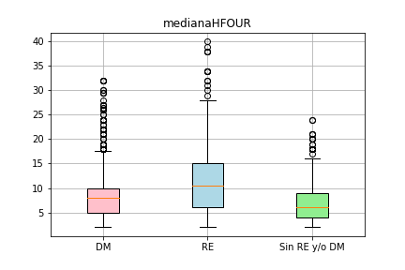

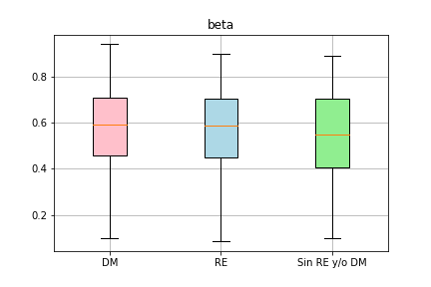 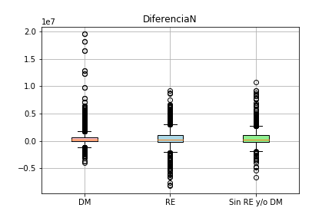 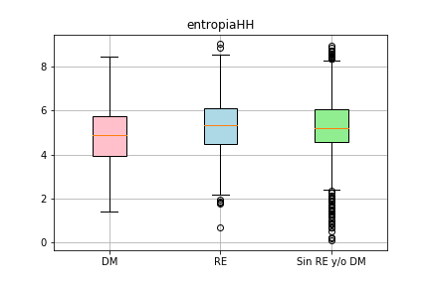

VENTANA 150X150

* MEJORES RESULTADOS

|  |  |  |  |  |  |  |  |
| --- | --- | --- | --- | --- | --- | --- | --- |
| **Espacio de color** | **Características** | **p(matlab)** |  |  | **p(Python)** |  |  |
| **B** | **asimetriaHFOUR** | 6,2725E-63 | 3,1313E-10 | 3,7102E-29 | 6,27E-63 | 3,13E-10 | 3,71E-29 |
|  | **destanEDFT** | 0,00128129 | 2,6998E-64 | 1,2398E-82 | 0,001281 | 2,7E-64 | 1,24E-82 |
|  | **CurtosHFOUR** | 2,7789E-55 | 1,0377E-06 | 8,2487E-33 | 2,78E-55 | 1,04E-06 | 8,25E-33 |

* PEORES RESULTADOS

|  |  |  |  |  |  |  |  |
| --- | --- | --- | --- | --- | --- | --- | --- |
| **Espacio de color** | **Características** | **p(matlab)** |  |  | **p(Python)** |  |  |
| **B** | **mediaHH** | 0,77014152 | 0,6615703 | 0,56094974 | 0,770142 | 0,66157 | 0,56095 |
|  | **asimetriaEDFT** | 0,01369948 | 0,90292897 | 0,0173375 | 0,013699 | 0,902929 | 0,017338 |
|  | **Disimilitud** | 0,65583401 | 0,61995027 | 0,96067508 | 0,655834 | 0,61995 | 0,960675 |

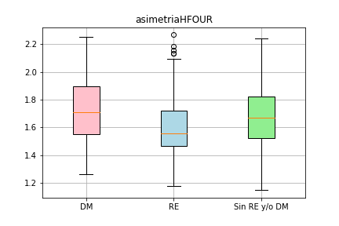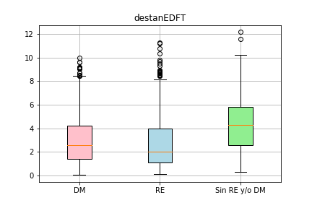 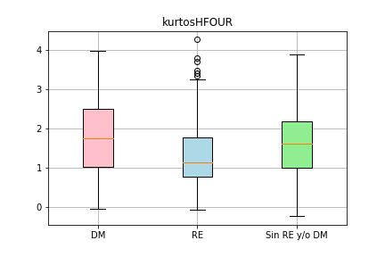

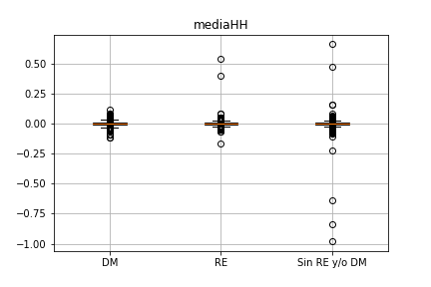 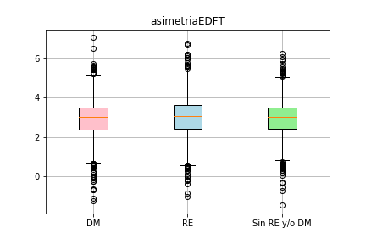 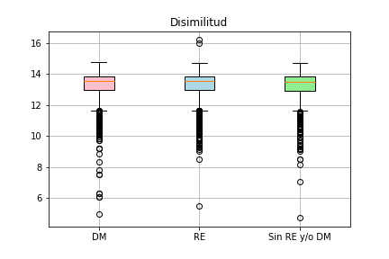

VENTANA 50X50

* MEJORES RESULTADOS

|  |  |  |  |  |  |  |  |
| --- | --- | --- | --- | --- | --- | --- | --- |
| **Espacio de color** | **Características** | **p(matlab)** |  |  | **p(Python)** |  |  |
| **V** | **asimetriaHFOUR** | 5,297E-258 | 9,571E-13 | 1,667E-177 | 5,3E-258 | 9,57E-13 | 1,7E-177 |
|  | **varlaplacianaV** | 0,45010433 | 7,238E-119 | 2,884E-115 | 0,450104 | 7,2E-119 | 2,9E-115 |
|  | **Correlación** | 2,87E-154 | 6,1188E-20 | 2,873E-295 | 2,9E-154 | 6,12E-20 | 2,9E-295 |

* PEORES RESULTADOS

|  |  |  |  |  |  |  |  |
| --- | --- | --- | --- | --- | --- | --- | --- |
| **Espacio de color** | **Características** | **p(matlab)** |  |  | **p(Python)** |  |  |
| **V** | **brillomediana** | 0,98490814 | 4,5408E-33 | 1,8477E-32 | 0,984908 | 4,54E-33 | 1,85E-32 |
|  | **maxderivadaEDFT** | 3,1099E-91 | 0,90656411 | 2,1441E-89 | 3,11E-91 | 0,906564 | 2,14E-89 |
|  | **betaDWHT** | 0,81750036 | 0,65168518 | 0,86680243 | 0,8175 | 0,651685 | 0,866802 |

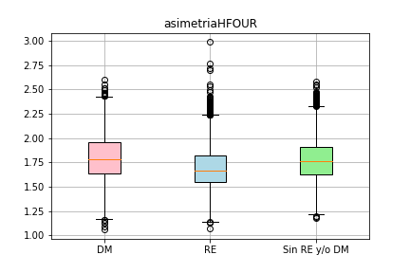 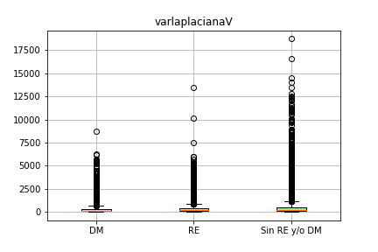 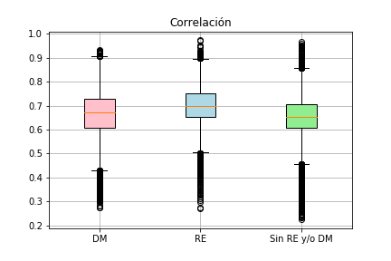

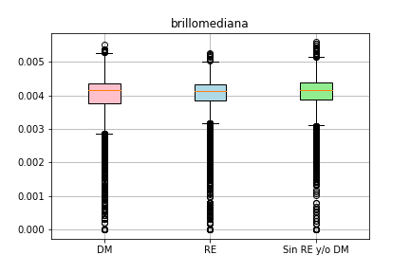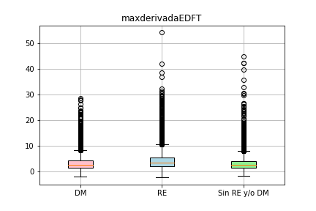 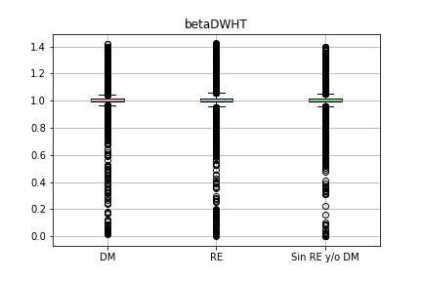

VENTANA 50X50

* MEJORES RESULTADOS

|  |  |  |  |  |  |  |  |
| --- | --- | --- | --- | --- | --- | --- | --- |
| **Espacio de color** | **Características** | **p(matlab)** |  |  | **p(Python)** |  |  |
| **S** | **entropiaHH** | 1,369E-145 | 2,4529E-87 | 0,00012176 | 1,4E-145 | 2,45E-87 | 0,000122 |
|  | **medianaHFOUR** | 7,5781E-48 | 1,305E-132 | 0 | 7,58E-48 | 1,3E-132 | 0 |
|  | **Correlación** | 3,974E-106 | 5,4257E-33 | 2,279E-271 | 4E-106 | 5,43E-33 | 2,3E-271 |

* PEORES RESULTADOS

|  |  |  |  |  |  |  |  |
| --- | --- | --- | --- | --- | --- | --- | --- |
| **Espacio de color** | **Características** | **p(matlab)** |  |  | **p(Python)** |  |  |
| **S** | **brillomediana** | 0,98490814 | 4,5408E-33 | 1,8477E-32 | 0,984908 | 4,54E-33 | 1,85E-32 |
|  | **betaN** | 1,9565E-16 | 0,98603678 | 1,2963E-16 | 1,96E-16 | 0,986037 | 1,3E-16 |
|  | **varLH** | 3,791E-24 | 1,9383E-39 | 0,99231746 | 3,79E-24 | 1,94E-39 | 0,992317 |

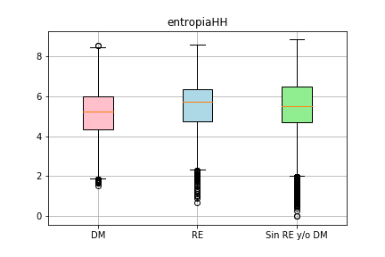 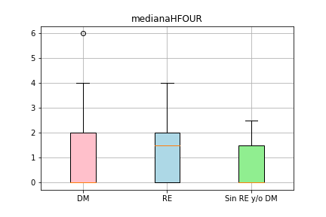 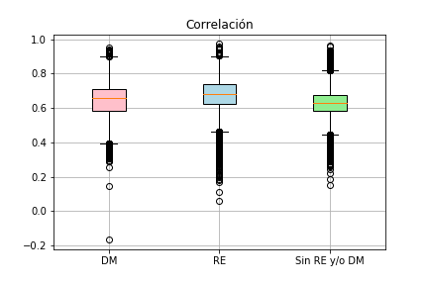

 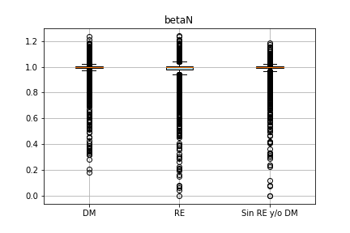 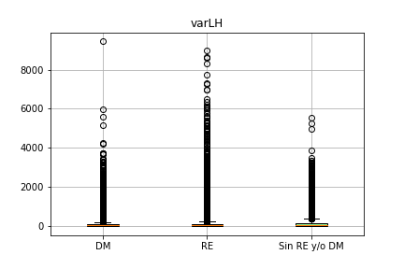

VENTANA 50X50

* MEJORES RESULTADOS

|  |  |  |  |  |  |  |  |
| --- | --- | --- | --- | --- | --- | --- | --- |
| **Espacio de color** | **Características** | **p(matlab)** |  |  | **p(Python)** |  |  |
| **B** |  |  |  |  |  |  |  |
|  |  |  |  |  |  |  |  |
|  |  |  |  |  |  |  |  |
|  |  |  |  |  |  |  |  |
|  |  |  |  |  |  |  |  |
|  |  |  |  |  |  |  |  |

* PEORES RESULTADOS

|  |  |  |  |  |  |  |  |
| --- | --- | --- | --- | --- | --- | --- | --- |
| **Espacio de color** | **Características** | **p(matlab)** |  |  | **p(Python)** |  |  |
| **B** |  |  |  |  |  |  |  |
|  |  |  |  |  |  |  |  |
|  |  |  |  |  |  |  |  |
|  |  |  |  |  |  |  |  |
|  |  |  |  |  |  |  |  |
|  |  |  |  |  |  |  |  |